广东白云学院

《设计模式》实验报告书

行为型模式 （职责链模式、命令模式）

学生姓名：_____梁发灿____________
学 号：_____202202150353_________
班 级：____A22软件工程7班______
指导老师：____齐勇军____________
专 业：_____软件工程__________

提交日期：2023年5月

- 案例分析
1．某OA系统需要提供一个假条审批的模块，如果员工请假天数小于3天，主任可以审批该假条；如果员工请假天数大于等于3天，小于10天，经理可以审批；如果员工请假天数大于等于10天，小于30天，总经理可以审批；如果超过30天，总经理也不能审批，提示相应的拒绝信息。
- 选择职责链模式设计。
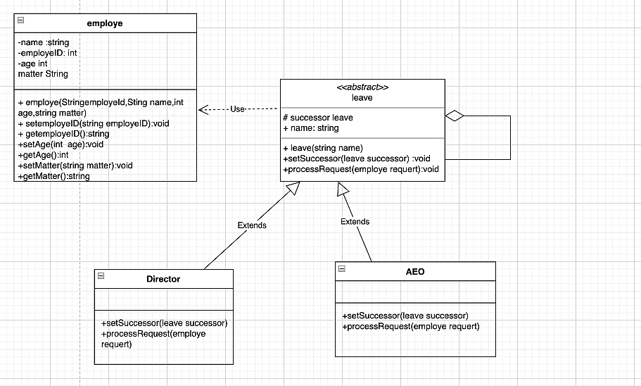
- 编写程序代码。
/**
*员工
*/
public class employe {
private String name;
private int employeId;
private int age;
private String matter;
private int day;
public employe(String name, int employeId, int age, String matter, int day) {
this.name = name;
this.employeId = employeId;
this.age = age;
this.matter = matter;
this.day = day;
}
public int getDay() {
return day;
}
public void setDay(int day) {
this.day = day;
}
public String getName() {
return name;
}
public void setName(String name) {
this.name = name;
}
public int getEmployeId() {
return employeId;
}
public void setEmployeId(int employeId) {
this.employeId = employeId;
}
public int getAge() {
return age;
}
public void setAge(int age) {
this.age = age;
}
public String getMatter() {
return matter;
}
public void setMatter(String matter) {
this.matter = matter;
}
}
package zhize;
/**
请假
*/
public abstract class leave {
protected leave successtor;
protected String name;
public leave(String name) {
this.name = name;
}
public void setSuccesstor(leave successtor) {
this.successtor = successtor;
}
abstract void proccessRequest(employe employe);
}
package zhize;
/**
*主任
*/
public class Director extends leave{
public Director(String name) {
super(name);
}
@Override
void proccessRequest(employe employe) {
if(employe.getDay()>=3 && employe.getDay()<=10){
System.out.println("主任"+this.name+" "+
"审批事情假条:"+employe.getMatter()+" "+
"申请人的名字："+employe.getName()+" "+
" 申请人的年龄："+employe.getAge()+" "+
"申请人的编号："+employe.getEmployeId());
}else {
//经理处理
this.successtor.proccessRequest(employe);
}
}
}
package zhize;
/**
* 经理
*/
public class AOE extends leave {
public AOE(String name) {
super(name);
}
@Override
void proccessRequest(employe employe) {
if(employe.getDay()>=10 && employe.getDay()<=30){
System.out.println("经理"+this.name+" "+
"审批事情假条:"+employe.getMatter()+" "+
"申请人的名字："+employe.getName()+" "+
" 申请人的年龄："+employe.getAge()+" "+
"申请人的编号："+employe.getEmployeId());
}else {
//经理处理
System.out.println("请假时间过长，经理驳回");
}
}
}

package zhize;
/**
* 客户
*/
public class client {
public static void main(String[] args) {
employe zhagnsan,lisi,wangwu;
zhagnsan=new employe("张三",1,18,"外出旅游",5);
lisi=new employe("李四",2,13,"发烧",10);
wangwu =new employe("王五",3,20,"摆烂",40);
leave li,aoe;
li=new Director("李主任");
aoe=new AOE("潘");
li.setSuccesstor(aoe);
//请假人
li.proccessRequest(zhagnsan);
aoe.proccessRequest(lisi);
//转发
li.proccessRequest(wangwu);
}
}

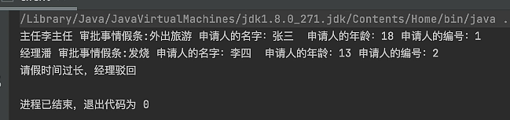
2．设计一套智能生活项目，某家庭买了一套智能家电，与照明灯、风扇、冰箱、洗衣机，只要在手机上安装一个APP就可以控制这些家电工作。
- 选择命令模式设计。
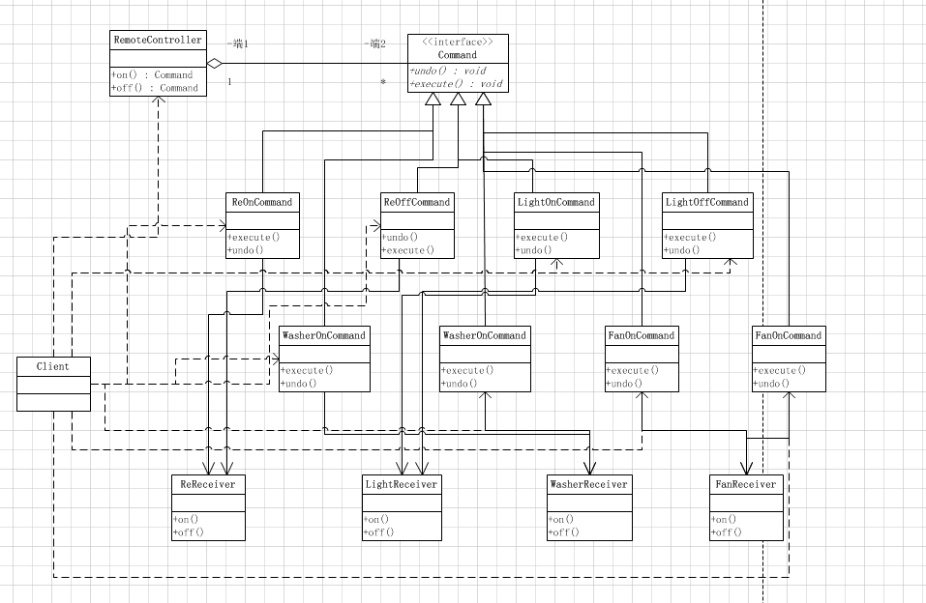
- 编写程序代码。
//创建命令接口
public interface Command {
//执行动作(操作)
public void execute();
//撤销动作(操作)
public void undo();
}

public class FanOffCommand implements Command {
//聚合LightReceiver
FanReceiver fan;
//构造器
public FanOffCommand(FanReceiver fan) {
super();
this.fan = fan;
}
@Override
public void execute() {
// TODO Auto-generated method stub
//调用接收者的方法
fan.off();
}
@Override
public void undo() {
// TODO Auto-generated method stub
//调用接收者的方法
fan.on();
}
}

public class FanOnCommand implements Command{
//聚合LightReceiver
FanReceiver fan;
//构造器
public FanOnCommand(FanReceiver fan) {
super();
this.fan = fan;
}
@Override
public void execute() {
// TODO Auto-generated method stub
//调用接收者的方法
fan.on();
}
@Override
public void undo() {
// TODO Auto-generated method stub
//调用接收者的方法
fan.off();
}
}

public class FanReceiver {
public void on() {
System.out.println(" 风扇打开了.. ");
}
public void off() {
System.out.println(" 风扇关闭了.. ");
}
}

public class LightOffCommand implements Command{
// 聚合LightReceiver
LightReceiver light;
// 构造器
public LightOffCommand(LightReceiver light) {
super();
this.light = light;
}
@Override
public void execute() {
// TODO Auto-generated method stub
// 调用接收者的方法
light.off();
}
@Override
public void undo() {
// TODO Auto-generated method stub
// 调用接收者的方法
light.on();
}
}

public class LightOnCommand implements Command{
//聚合LightReceiver
LightReceiver light;
//构造器
public LightOnCommand(LightReceiver light) {
super();
this.light = light;
}
@Override
public void execute() {
// TODO Auto-generated method stub
//调用接收者的方法
light.on();
}
@Override
public void undo() {
// TODO Auto-generated method stub
//调用接收者的方法
light.off();
}
}

// 命令的真正执行者
public class LightReceiver {
public void on() {
System.out.println(" 照明灯打开了.. ");
}
public void off() {
System.out.println(" 照明灯关闭了.. ");
}
}

//控制器
public class RemoteController {
// 开 按钮的命令数组
Command[] onCommands;
Command[] offCommands;
// 执行撤销的命令
Command undoCommand;
// 构造器，完成对按钮初始化
public RemoteController() {
onCommands = new Command[5];
offCommands = new Command[5];
}
// 给我们的按钮设置你需要的命令
public void setCommand(int no, Command onCommand, Command offCommand) {
onCommands[no] = onCommand;
offCommands[no] = offCommand;
}
// 按下开按钮
public void onButtonWasPushed(int no) { // no 0
// 找到你按下的开的按钮， 并调用对应方法
onCommands[no].execute();
// 记录这次的操作，用于撤销
undoCommand = onCommands[no];
}
// 按下开按钮
public void offButtonWasPushed(int no) { // no 0
// 找到你按下的关的按钮， 并调用对应方法
offCommands[no].execute();
// 记录这次的操作，用于撤销
undoCommand = offCommands[no];
}
// 按下撤销按钮
public void undoButtonWasPushed() {
undoCommand.undo();
}
}

public class ReReceiver {
public void on() {
System.out.println(" 冰箱打开了.. ");
}
public void off() {
System.out.println(" 冰箱关闭了.. ");
}
}

public class ReOffCommand implements Command {
// 聚合TVReceiver
ReReceiver re;
// 构造器
public ReOffCommand(ReReceiver tv) {
super();
this.re = tv;
}
@Override
public void execute() {
// TODO Auto-generated method stub
// 调用接收者的方法
re.off();
}
@Override
public void undo() {
// TODO Auto-generated method stub
// 调用接收者的方法
re.on();
}
}

public class ReOnCommand implements Command{
// 聚合TVReceiver
ReReceiver re;
// 构造器
public ReOnCommand(ReReceiver tv) {
super();
this.re = tv;
}
@Override
public void execute() {
// TODO Auto-generated method stub
// 调用接收者的方法
re.on();
}
@Override
public void undo() {
// TODO Auto-generated method stub
// 调用接收者的方法
re.off();
}
}

public class WasherOffCommand implements Command {
// 聚合TVReceiver
WasherReceiver wa;
// 构造器
public WasherOffCommand(WasherReceiver wa) {
super();
this.wa = wa;
}
@Override
public void execute() {
// TODO Auto-generated method stub
// 调用接收者的方法
wa.off();
}
@Override
public void undo() {
// TODO Auto-generated method stub
// 调用接收者的方法
wa.on();
}
}

public class WasherOnCommand implements Command{
// 聚合TVReceiver
WasherReceiver wa;
// 构造器
public WasherOnCommand(WasherReceiver wa) {
super();
this.wa = wa;
}
@Override
public void execute() {
// TODO Auto-generated method stub
// 调用接收者的方法
wa.on();
}
@Override
public void undo() {
// TODO Auto-generated method stub
// 调用接收者的方法
wa.off();
}
}

public class WasherReceiver {
public void on() {
System.out.println(" 洗衣机打开了.. ");
}
public void off() {
System.out.println(" 洗衣机关闭了.. ");
}
}

public class Client {
public static void main(String[] args) {
//使用命令设计模式，完成通过遥控器，对电灯的操作
//创建电灯的对象(接受者)
LightReceiver lightReceiver = new LightReceiver();
//创建电灯相关的开关命令
LightOnCommand lightOnCommand = new LightOnCommand(lightReceiver);
LightOffCommand lightOffCommand = new LightOffCommand(lightReceiver);
//需要一个遥控器
RemoteController remoteController = new RemoteController();
//给我们的遥控器设置命令, 比如 no = 0 是电灯的开和关的操作
remoteController.setCommand(0, lightOnCommand, lightOffCommand);
System.out.println("--------按下灯的开按钮-----------");
remoteController.onButtonWasPushed(0);
System.out.println("--------按下灯的关按钮-----------");
remoteController.offButtonWasPushed(0);
System.out.println("--------按下撤销按钮-----------");
remoteController.undoButtonWasPushed();
System.out.println("=========使用遥控器操作冰箱==========");
ReReceiver tvReceiver = new ReReceiver();
ReOffCommand tvOffCommand = new ReOffCommand(tvReceiver);
ReOnCommand tvOnCommand = new ReOnCommand(tvReceiver);
//给我们的遥控器设置命令, 比如 no = 1 是冰箱的开和关的操作
remoteController.setCommand(1, tvOnCommand, tvOffCommand);
System.out.println("--------按下冰箱的开按钮-----------");
remoteController.onButtonWasPushed(1);
System.out.println("--------按下冰箱的关按钮-----------");
remoteController.offButtonWasPushed(1);
System.out.println("--------按下撤销按钮-----------");
remoteController.undoButtonWasPushed();
System.out.println("=========使用遥控器操作风扇==========");
FanReceiver fanReceiver = new FanReceiver();
FanOffCommand fanOffCommand = new FanOffCommand(fanReceiver);
FanOnCommand fanOnCommand = new FanOnCommand(fanReceiver);
//给我们的遥控器设置命令, 比如 no = 2 是风扇的开和关的操作
remoteController.setCommand(2, fanOnCommand, fanOffCommand);
System.out.println("--------按下风扇的开按钮-----------");
remoteController.onButtonWasPushed(2);
System.out.println("--------按下风扇的关按钮-----------");
remoteController.offButtonWasPushed(2);
System.out.println("--------按下撤销按钮-----------");
remoteController.undoButtonWasPushed();
System.out.println("=========使用遥控器操作洗衣机==========");
WasherReceiver washerReceiver = new WasherReceiver();
WasherOffCommand washerOffCommand = new WasherOffCommand(washerReceiver);
WasherOnCommand washerOnCommand = new WasherOnCommand(washerReceiver);
//给我们的遥控器设置命令, 比如 no = 3 是洗衣机的开和关的操作
remoteController.setCommand(3, fanOnCommand, fanOffCommand);
System.out.println("--------按下洗衣机的开按钮-----------");
remoteController.onButtonWasPushed(3);
System.out.println("--------按下洗衣机的关按钮-----------");
remoteController.offButtonWasPushed(3);
System.out.println("--------按下撤销按钮-----------");
remoteController.undoButtonWasPushed();
}
}

运行结果：
